Instructions for BRM709 Hokkaido 1200km “Cape Nosappu”
Thank you for your registration for BRM709 Hokkaido 1200km “Cape Nosappu”. We introduce you about the schedule and rules in these instructions.

AJ Hokkaido representative: Ms. Naomi Nagase 090-8897-7032
Contact address: aj.hokkaido@gmail.com (Staff Mr. Hiroshi Horikawa)

【Outline】
Type: RM approved BRM 1200km
Sponsorship: AJ Hokkaido
Support: City of Sapporo, City of Kitami, Board of Education in Minamifurano Town, City of Nemuro, Board of Education in Betsukai Town.
Meeting point: Satoland Farm Park Center (City of Sapporo) (Start/Finish).
Reception time: 13:00 to 19:00, 9th July, 2014 (Wednesday)
Departure time: 21:00, 9th July, 2014 (Wednesday)
Time limit: 90 hours (from 21:00, 9th July, 2014 (Wednesday) to 15:00, 13th July, 2014 (Sunday)).
Course: City of Sapporo, Satoland ⇔ City of Ashibetsu ⇔ Minamifurano Town ⇔ Ashoro Town ⇔ City of Kitami ⇔ Betsukai Town ⇔ City of Nemuro, Cape Nosappu (Round-trip, 1200km)
Number of participants: About 150 randonneurs
Documents: Cue sheet and course map (outline of the whole course) (Please download by oneself from the AJ Hokkaido website)

【Rules】
1. Basic matters
・This event is operated based on the RM (Randonneurs Mondiaux) regulation.
・Please participate after understanding BRM/AJ regulations.
http://www.audax-japan.org/BRM-part-regulation.html
・[Separate sheet] Please sign the document which we will ask you at the reception to confirm that you agree the content of the document Waiver for BRM709 Hokkaido 1200km “Cape Nosappu”
・Follow the traffic regulation and related registrations. When the discovery or report of any offence (e.g. disregarding a traffic signal), we have right to disqualify the person’s participation to the Brevet.
・The organizer does not have any responsibility to any of the accidents during the BRM by yourself, and report it to organizer or management staff without any delay.

2. Duty equipment
- Headlight (two lights or more are duty. We recommend you to prepare spare light also)
・Please fix lights to the bicycle body.
・Light attached to the helmet is not included in the number of the headlight.
・Headlights are fixed at all times, and ready for use.
・Lights must be turned on from evening to the dawn.
・Not only at night, you must turn on lights in the tunnel, and at poor visibility such as rain or fog.
・Even when you are riding in the group, you must use your own lights.
(2) Rear light (one light or more is duty)
・ Please fix at least one rear light to the main body of bicycle (frame, seat pillar, etc.) surely.
・ Blinking mode is not allowed.
(3) Reflection tool (required to wear on upper body wearing)
・ Please wear the reflection vest, or similar wearing with reflection materials in front and back during the ride.
・ Put the reflection tool in the daytime as well as in the night. (AJH local rule)
・ Use only a reflective sash is not allowed. (AJH local rule)
(4) Helmet (indispensable)
・Impose a duty of wearing helmet by the Road Traffic Law and insurance.
(AJ original regulation)
(5) Bell (indispensable)
・Impose a duty of carrying bell by the Road Traffic Law and insurance.
(AJ original regulation)
・Please fix the bell to the main part of the bicycle.
(6) Helmet tail light (indispensable) (AJ original regulation)
・The visibility from a succession vehicle improves. (Use in blink mode is allowed)

3. The Recommended Equipment (with no obligation)
(1) The light attached to the helmet
・It is useful when you check a road sign (to keep away from miss course) at night, the hand lighting at the time of flat repair, checking a cue sheet, a map, cycle computer, etc.
(2) Rescue sheet (survival sheet)
・It is useful when you need to stand outdoors in the cold weather.

[How to round a course]
・The route uses same course for going and returning which makes the "Nosappu cape" as a point of return.
・The PCs are as follows.
ＰＣ number | ＰＣ name | Receipt check | Staff check
ＰＣ１・ＰＣ９ | Seven Eleven “Kamiashibetsu”  (Lawson “Ashibetu Kamiashibetsu” is also available) | ✔
ＰＣ２・ＰＣ８ | Lake Kanayama Sports Training Center |  | ✔
ＰＣ３・ＰＣ７ | Seven Eleven “Asyoro -Shimoaikappu” | ✔
ＰＣ４・ＰＣ６ | Kitami-city Natural Relaxation Village Center |  | ✔
ＰＣ５ | Nosappu hall |  | ✔

・At he PC with receipt check, buy anything at the shop indicated as the PC, then hand the receipt of your shopping to the staff who is waiting in the next PC. The time indicated on the receipt is used as the passing time of the PC.
・Leaving from a route for shopping, repair, etc. is not violation of Brevet. But in that case, please be sure to run an official route after returning to the point of the origin from which you separated in that case.
*Special instruction for PC1/9 Seven Eleven “Kamiashibetsu”.
In the case of PC1/9, we accept the shopping receipt of Lawson “Ashibetsu Kamiashibetsu” which is located about 300 m before from the original PC (Seven Eleven “Kamiashibetsu”) on the outward journey.

【Break point】
Following PCs are break points and nap place where officially prepared by the organizer. Except for Lake Kanayama Hoyo center and Betsukai Townsman gymnasium, they are also PCs.

Break point | ＰＣ | Remark
Lake Kanayama Sports Training Center | PC2, PC8
Lake Kanayama Recreation Center |  | Available on return journey
Kitami-city Natural Relaxation Village Center | PC4, PC6
Betsukai chomin gymnasium
Nosappu Hall | PC5

1. PC2, PC8 Lake Kanayama Sports Training Center
http://www.donkoro.com/?page_id=150
【Staff leader】 Mr. Yuichi Kishi 090-9083-0273
Parking place: Lean your bike against the circumference of the building, or lay your bike down on the lawn of building right and left.
Entrance: Center of the front.
PC reception desk: In the second floor. You may have information about the route.
Nap place: Japanese style rooms (for Male and Female separately) and a large hall. Blanket and the pillow will be served.
Meal offer: A light meal, drink, banana, mineral water, etc. (There is the possibility of change)
Bath: Only shower for male and female (two for each).
Others: No drop bag service.

2. Lake Kanayama Recreation Center (Only available on return journey)
http://larch.jp/hoyou.center/hoyou.center.html
【Staff leader】Mr. Yuichi Kishi 090-9083-0273
Place: About 200m from PC8 (Lake Kanayama Sports Training Center). The other side across the road.
Parking place: Lay your bike down on the lawn of building front and left, or lean it against adjacent BBQ house.
Entrance: Only use front left-hand side. (General visitors use the right-hand side entrance.)
Reception: Staff or the training center staff waits for your arrival.
Nap place for male: Two Japanese-style rooms at the second floor (offer blanket and pillow).
Nap place for female: There is an exclusive room in the sports training center.
Bath: Public bath.
Warning: This place is NOT PC. Please use this place after taking PC8 (Sports Training Center). Lobby and bathroom are not charters. Be careful for the settlement of your load and warn not to become the ordinary visitors' trouble.

3. PC4, PC6 Kitami-shi Natural Relaxation Village Center (The largest nap place, the drop bag is placed)
http://www14.ocn.ne.jp/~kousya/kyu_h.html
【Staff leader】Mr. Kazuyuki Sasaki 090-5226-1189
Parking place: Prefab house in the site.
Nap place: Japanese-style room sharing a room with futon and sheet. Male and Female use different room.
(NOTE) As you will use the same room and futon on the way back, please leave “Entry number display sheet” near the pillow.
- Assignment of rooms should follow a local staff's directions.
- No alarm service by the staff.
Food: The meal performs a plan of Japanese traditional soup with pork (Butajiru) (outward trip), curry (return trip) and rice, bread, salad, etc. (There is the possibility of change)
Bath: Large public bath.
Other facilities: Shower, laundry, vending machine for beverage (coffee, juice, etc.) is available in the facility. There are no adjacent convenience store facilities. (There is a convenience store in the city of Kitami)

4. Betsukai chomin gymnasium
http://betsukai.jp/blog/0002-2/index.php?ID=139
【Staff leader】Mr. Kazuyuki Hosoya 090-6210-4518
Parking place: ???
Nap place: Large scale arena with flooring with blanket.
Food: Bread of the local bakery will be offered (there is a change).
Bath: Shower (about 3 sets), and stretch mat (about 20).
Others: No drop bag.
* Special notes about the route:
Though "The Betsukai townsman gymnasium" is set up on the course, it is an option of the participants because it is not a PC.
If the participant if he/her does not drop here, the following routes are the route to appoint in a cue sheet.
(Refer cue sheet and attached map).
At the outward trip, do not turn to the right at No. 62 and go straight on in R243, and turn right at crossing 1.1k ahead. Go 0.7k and return to the regular route at No. 65.
At the return trip, do not turn left at No. 77 and go straight on in R243, and turn left at crossing 1.1k ahead. Go 1.1k and return to the regular route at No. 80.

5. PC5 Nosappu Kaikan (A small-scale rest facility)
【Staff leader】Mr. Tadafumi Nomura 090-3672-8498
Parking place: Around the building or on the turf.
Nap place: Hall for man and woman, separately. Offer blanket.
Food: Carry food (there is a change).
Bath: no bath, no shower.
Others: Restaurant is in the neighborhood. (“Tomoshibi” from 830 to 1730 – payment each one)

[About the drop bag and baggage storage]
1. Drop bag
Drop bag of your baggage is performed in the Kitami Natural Relaxation Village Center (PC4 and PC6).
If the participant plans to use drop bag please refer the following instruction and bring your bag/box to the reception desk at the starting point by 19:00. You may have a tag when you deposit your bag/box. You are able to deposit your bag/box newly at PC4 and PC6 also.
(1) Limitation of the number and volume, etc.
- Only one baggage per participant about a maximum of 25 liters. (In case of a box, the size of the box should be within 100cm (sum of horizontal and height) Please prepare bag or box by participant himself or herself.
- Please be sure to close and seal tightly the box not to fall out the contents, and do not put any valuable things in it. AJ Hokkaido DOES NOT have any responsibility for the content.
- Please understand and cooperate for freight restrictions of a transit vehicle.
(2) Baggage deposit at the starting point
- Please put the tag (with entry number) which you receive at the reception, to the drop bag, then hand it to the staff at the reception desk by 19:00.
- If you use a box, please indicate your name on the top side of the box.
(3) Baggage receipt at PC4 and PC6.
- Please show your brevet card (or the tag) when you receive your drop bag.
- Please receive your drop bag within PPC4 and PC6 open time.
- Do not take off the tag (with entry number) on the drop bag at all the time.
(4) Baggage deposit at PC4 and PC6
- You are able to deposit your drop bag with the tag you have at PC4 and PC6 again. Please keep the tag attached to the drop bag.
- In addition, we will accept your deposit of baggage in PC4 and PC6 newly (you need to prepare the bag/box by yourself).
- The deadline of the baggage deposit at PC6 is 12:00 12th July (Saturday). Your drop bag will be transported to the goal after the closure of PC6.
(5) Baggage receipt at the goal.
- The time you are able to receive your bag/box at the goal: 12th July (Saturday) 22:00 to 13th July (Sunday) 16:00.
- Please receive your drop bag in exchange for the tag after you have arrived.

2. Baggage storage at the Start point.
(1) How to deposit your baggage.
- You can deposit your baggage at the start point, and the baggage will be stored by the end of the brevet. Neither the number nor a size has restriction.
- The staff will hand you a tag (with entry number), then put the tag to the baggage and hand it to the staff at the reception by 19:00 of the departure day.
- You may receive your baggage(s) in exchange for the tag after goal.
(2) Important notes for baggage custody.
- You can not take any responsibility in the organizer (AJ Hokkaido) side when there are loss or breakage about the contents and/or baggage itself. Please use Drop bag and deposit after consent beforehand.
- Please do not include any valuables. In addition, please make sure to carry out suitable treatment to the fragile things.
(3) Important notes for baggage receipt.
- We will not send your baggage/bag or anything which may belong to you, to your house or other place even if you are in the case of DNF. Please come to the goal meeting place to undertake your baggage by all means.

【About support and retirement】
1. Way of thinking for the support
- Each participant has to perform all by himself/herself. Any support (including companion run by car or bicycle, etc.) by anybody other than participant are prohibited during a run. You can only accept the support by third party at PC.
- It is allowed to accept a help by other participants or third party who has not attached a support beforehand (a bicycle shop repairs is included).

2. Correspondence of a retirement, etc.
- In the case of a retirement, an accident, poor physical condition, time over, receipt loss, etc. please contact the staff as soon as possible. You can find the contact phone number on the Brevet card. Each participant should perform the accident by oneself.
*Emergency contact information of the domestic participant:
Organizer: Ms. Naomi Nagase 090-8897-7032
*Emergency contact information of the overseas participant:
Staff: Mr. Hiroshi Horikawa 090-7510-9164
Staff: Ms. Maya Ide 090-4710-4939
- In the case of DNS (Do Not Start), do not forget to inform the staff beforehand.
- In the case of retirement, please secure transportation by yourself and return to the start point, or go home directly. We (AJ Hokkaido) DO NOT perform (include arrangements) of collection of participant or bicycle, etc.

[About judgment of the cancellation of the Brevet]
When the organizer (AJ Hokkaido) judges the cancellation, it is decided depending on the situation without identifying it beforehand at the time. It can stop after a start. Even if it continues the event, we (AJ Hokkaido) do not secure a participant’s safety. Participant should take his/her correspondence such as interruption, the wait, etc. in his/her own judgment and responsibility. In the case of holding and continuation of the Brevet event become impossible, participation fee is not refunded.

[Schedule on the start day]
1. Meeting point
Sapporo Satoland “Satoland Farm Park Center” (584-2, Okadama-choo, Higashi-ku, Sapporo, http://www.satoland.com/)
2. Registration time: 9th July (Wednesday), 13:00 – 19:00 (The acceptance is finished at 19:00)
3. How to perform reception.
(1) Signature to the document.
- [Separate sheet] Please read and sign the document of Waiver for BRM709 Hokkaido 1200km “Cape Nosappu” after agreement.
(2) Selection of the starting group.
Please request your choice of the starting time (approximately 5 minutes intervals with about 20 randonneurs together). It is to secure the safety of the participants just after the start.
(3) Receipt of Brevet card.
- You will have a Brevet card at the reception desk. On the brevet card, open and close time based on the time of starting group is indicated.
- Fill your address, name, etc. by the bike inspection and equipment check. (Bring with a writing instruments)
(4) Receipt of ordered jersey.
- If you ordered a jersey, please receive the number of the orders, size after confirmation at a reception desk.
(5) Inspection
- After registration, please finish “the bike inspection and equipment check” immediately. The staff will sign on the Brevet card if you pass. In case of any defects please correct it by start time and be checked again.
(6) Drop bag and baggage custody.
- Who want to ask the drop bag or deposit your baggage at the start meeting place, attach your tag (handed in a reception desk) and bring it to the counter of the reception desk juxtaposition.
(7) Free food booth
- From 18:00, Free food booth is opened in a start meeting place. Please carry out eating before a start, looking at the slide show of AJ Hokkaido.

4. Opening ceremony & briefing: From 19:00 to 19:40
- Staff will explain instructions at the briefing. Bring cue sheet and a writing instrument.

5. Race entry preparation: 20:00 to 20:30 (available for bike inspection)
6. Start: 20:30 to 21:00
- If your stat time comes, please gather at the start position, and get “race entry sign” on your brevet card by a staff then leave.
- Even if it is past start time, we accept your race entry until 22:00 (we will make “race entry sign”).

[Instructions during the event]
・Please keep in mind for manners not to be a nuisance to other users at the convenience stores or other places. Please cooperate by an action of the each all of you so that we are accepted with respect by the society. It is out of the question to dump garbage in the road.
Please take the responsibility of your action as Randonnee (cyclist).
・The road of Hokkaido is generally damaged by climate condition in the various places including a level difference and cave-in in. Please be careful about the road surfaces for the course whole enough.
・It is expected in the daytime after sunset that it is suddenly cold even if warm. Please prepare for the protection against the cold equipment carefully and also do not forget to include a possibility of raining.
・Please check the following AJ Hokkaido web site, in order to find the trial run and addition of instructions.
http://www3.rocketbbs.com/13/bbs.cgi?id=ajhokkai

[Instructions for car parking space of Satoland Farm Park Center]
・Though car parking is available at Satoland Farm Park Center during the event, as the parking space is limited we ask you to come by self-run as much as possible. A facility manger or AJ Hokkaido does not have responsibility for the accident or theft in a parking lot.
・Do not leave any valuables in the car.
・Please act not to become troublesome to citizens.

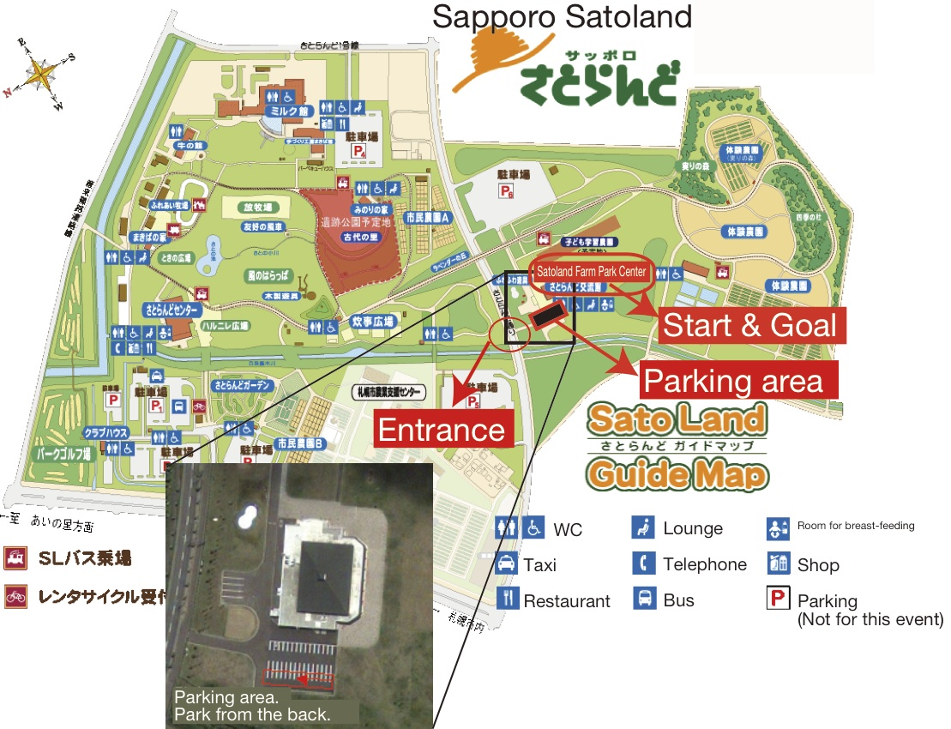

[Lake Kanayama Sport Training Center, Koryu center]
・ PC2 and8 Lake Kanayama Sport Training Center
Close to the Road 465, at the lake side of Lake Kanayama.
・Lake Kanayama Recreation Center
Close to the Road 465, at the mountain side of Lake Kanayama.
・About 200m between two facilities.
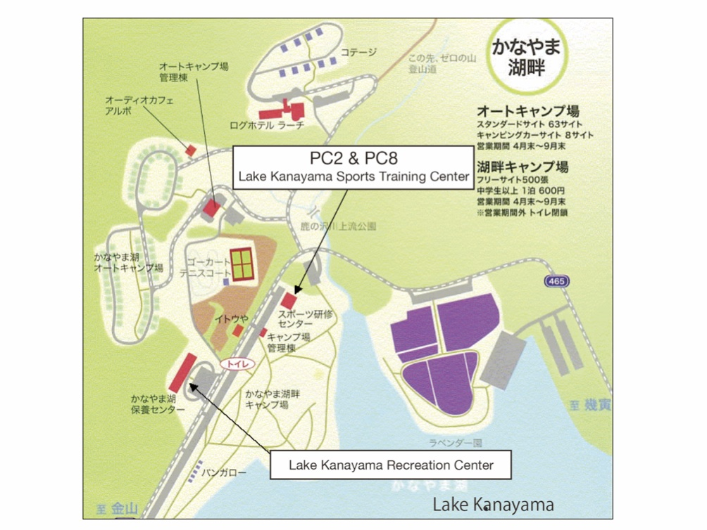
[Betsukai chomin gymnasium]
If you do not use Betsukai chomin gymnasium, it is allowed to use the blue dotted line indicated route on the map.

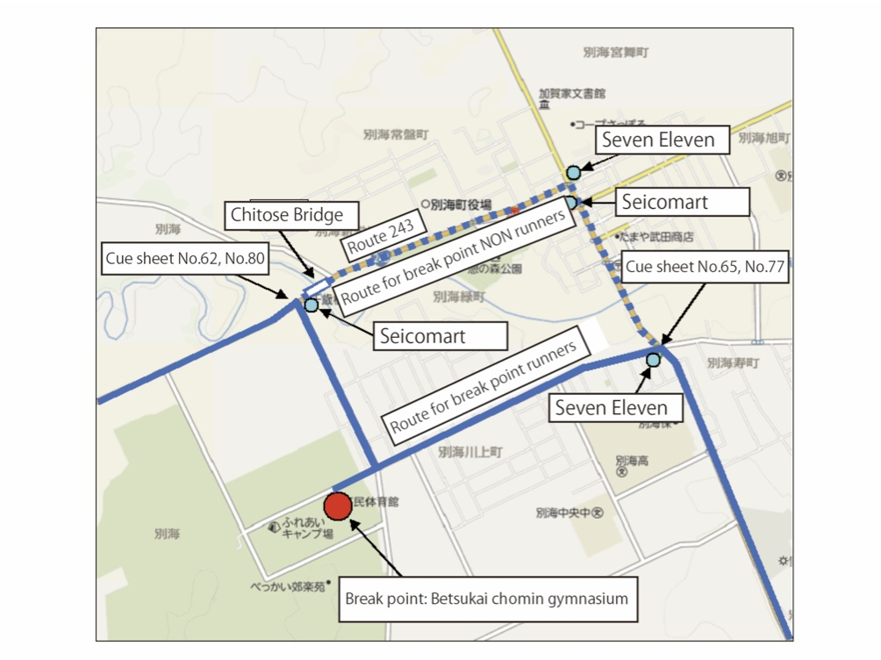
[Nosappu hall]
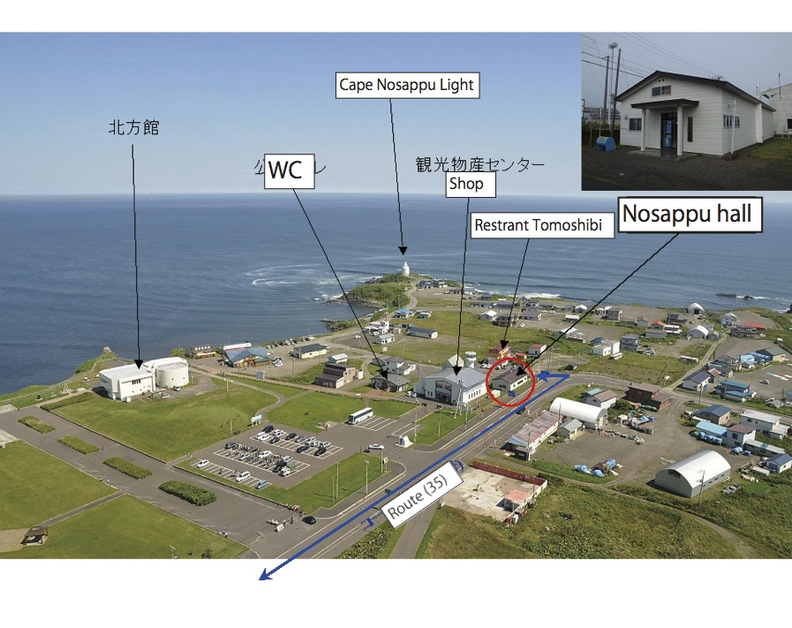

(Separate sheet)
Waiver for BRM709 Hokkaido 1200km “Cape Nosappu”
All participants must sign.

Waiver, release and indemnity to participate in events organized by AJ Hokkaido.

I acknowledge that I understand this waiver’s intent, and I, for myself, my heirs, executors, administrators, and representatives, do hereby agree and will absolve and hold harmless the organizers of this Brevet Randonneurs Mondiaux (herein called Event) hosted by accredited person by Audax Japan (AJ).

1. I understand the risks inherent in Randonneur events, and approve, agree, and declare that I am physically and mentally capable of participating in and have the qualification to participate in the Event. I agree and guarantee to withdraw immediately from the Event in my judgment, when I find it unsafe to continue for any reason, including fatigue, injury and accidents during the Event.

2. I understand that the Event takes place on public roadway and accept the possible risks during the Event. I agree and guarantee to observe all local traffic regulations (in Japan), and to follow traffic lights and signs. Furthermore, I agree and guarantee to withdraw immediately from the Event in my judgment, when I find weather or road conditions are unsafe.

3．I fully understand the followings:
(a) Sport of cycling can be dangerous, exposing participants to many risks and hazards (herein called Risks) including permanent physical disorder, paralysis, or death.
(b) These Risks may result from my own actions, from actions of other participants of the Event, from conditions of the Event, or from accidents incurred by third parties.
(c) There are known and currently unforeseen Risks and possibilities of social and economic losses. I fully accept all the Risks and responsibility for loss, expense and damage incurred by participating in the Event.

4. I hereby release and forever discharge and hold harmless and agree not to sue the organizers accredited by AJ, volunteers, and the owner or the lender of the premises on which the Event takes place (herein called Released Parties) of any expense, compensation request, liability, loss or damage arising from my participation in the Event. Furthermore, I agree that, when, regardless of this waiver, release and indemnity, I or my representative submit a request for compensations to members of Released Parties, I shall compensate and protect each of Released Parties for all lawsuit cost, lawyer fees, requested compensations, damages and expenses incurred by said request.

5. I agree to receive medical treatment in case I suffer injury or disease during the Event. And I agree to pay the fee for the medical treatment I received.

6．I permit my name, voice, photographs, and images to be used, free of charge, in radio broadcasting, in television broadcasting, on the Internet website, in visual recording, in newscast, and other uses related to the Event.

7. I agree not to request a refund of the participation fee when the Event is cancelled under unforeseen circumstances, such as bad weather or disaster, not responsible for the organizers.

8. I agree that I present/submit my insurance information/document upon signing up to the Event to confirm that I am adequately covered by an insurance which meets the requirement of AJ. I also agree that I am responsible to secure adequate insurance coverage.

9. I agree that in case the schedule of the Event is altered due to unforeseen conditions, such as bad weather or disaster, it is my responsibility to reaffirm the validity of my insurance under the altered schedule. I agree that, if I find my insurance is not valid under the altered schedule, I will inform the organizer and refrain from starting. I also agree that I will not request a refund of the participation fee in said circumstances.

I hereby confirm that I have read this document and have fully comprehended its conditions, that I understand that by signing this form I have given up my rights as described in this document, that I have voluntarily signed without any coercion or guarantee, that I understand that this completely waivers all responsibilities of Released Parties without any conditions within the laws, and that even in case any portion of this document be deemed void, remaining parts hold valid and effectual.

